Lazo, Benedict John R. BSIT 3-2  
Roxas, Von Emherlou



OPTIMIST BV:   
(Name of our Company)  
Marketing Research

Table of Content

Table of Content...............................................................................................................2

Introduction.......................................................................................................................3

Corporate Profile...............................................................................................................3

Research Method and Procedures...................................................................................3

Data Analysis and Findings..............................................................................................3

            SWOT analysis.....................................................................................................4

            Industry Analysis...................................................................................................4

                        Threat of New Entrants.............................................................................4

                        Bargaining Power of Buyer.......................................................................4

                        Bargaining power of supplier....................................................................5

                        Threat of substitutes.................................................................................5

                        Competitive rivalry between existing........................................................5

Conclusions and recommendations.................................................................................5

            Conclusions..........................................................................................................5

                        Awareness of the market..........................................................................6

                        Usage of the product................................................................................6

                        Buyer info.................................................................................................6

                        Patronage maintenance...........................................................................6

                        Brand image, slogan, ..............................................................................7

                        Strengths of the company.........................................................................7

                        Buying behavior of your target market......................................................7

            Recommendations................................................................................................7

Limitations.........................................................................................................................8

Appendix.

* 1. Product Image..................................................................................................8
  2. Infographic Image…………………………………………………………………..8

**Introduction**

   Optimist BV is an ICT consulting company that operates multi-lingual telesales, remote tech support call center, and customer support. They also do multimedia content marketing, advertising, and technology development which they’re popularly known for – wearable AI eyeglasses mainly for blinds and social media marketing department.

**Corporate Profile**

Company History: Optimist BV company was founded by Benedict Lazo and Von Roxas in January 2021, When the pandemic has begun, many industries worldwide like businesses, healthcare, finance, etc. have deployed and relied upon digital technology from traditional face to face work on many employees has shifted into work from home set up. The outsourcing industry also boomed and many businesses subcontracted their services to promote and assist their business.  Hence, Ben and Von ventured into an outsourcing business and technology development to help the lives of the PWD sector mainly visually impaired people.

Mission: To provide an efficient and extremely cost-effective service to the customers and enable your corporation to leverage global efficiencies so that businesses can operate like their physically connected to each other and help people make lives easier by leveraging technologies.

Vision: Optimist BV will be the number one partner of choice by providing quality services to enable clients’ long-term sustainable growth.

**Research Method and Procedures**

This company will collect relevant data through performed surveys, personal interviews – which we’ll be focusing on to get the best feedback from direct sources, and observations on focused groups and prospective clients about the current product in the market also how we’re going to improve it.   
 Below are the benefits that can be answered by our research method:

* What does our ideal customer look like?
* Questions about demographics, what their occupation is, what they like to do in their spare time
* Formulate best marketing strategies and campaigns.

**Data Analysis and Findings**

After gathering and analyzing all the collected data, now is the time to prove our hypothesis or assumptions to be true or false which is a contributing factor in making decisions on our marketing plan. Furthermore, the results will be our basis for constructing and developing our best marketing strategies and who are the ideal customers of our products.

**SWOT analysis**

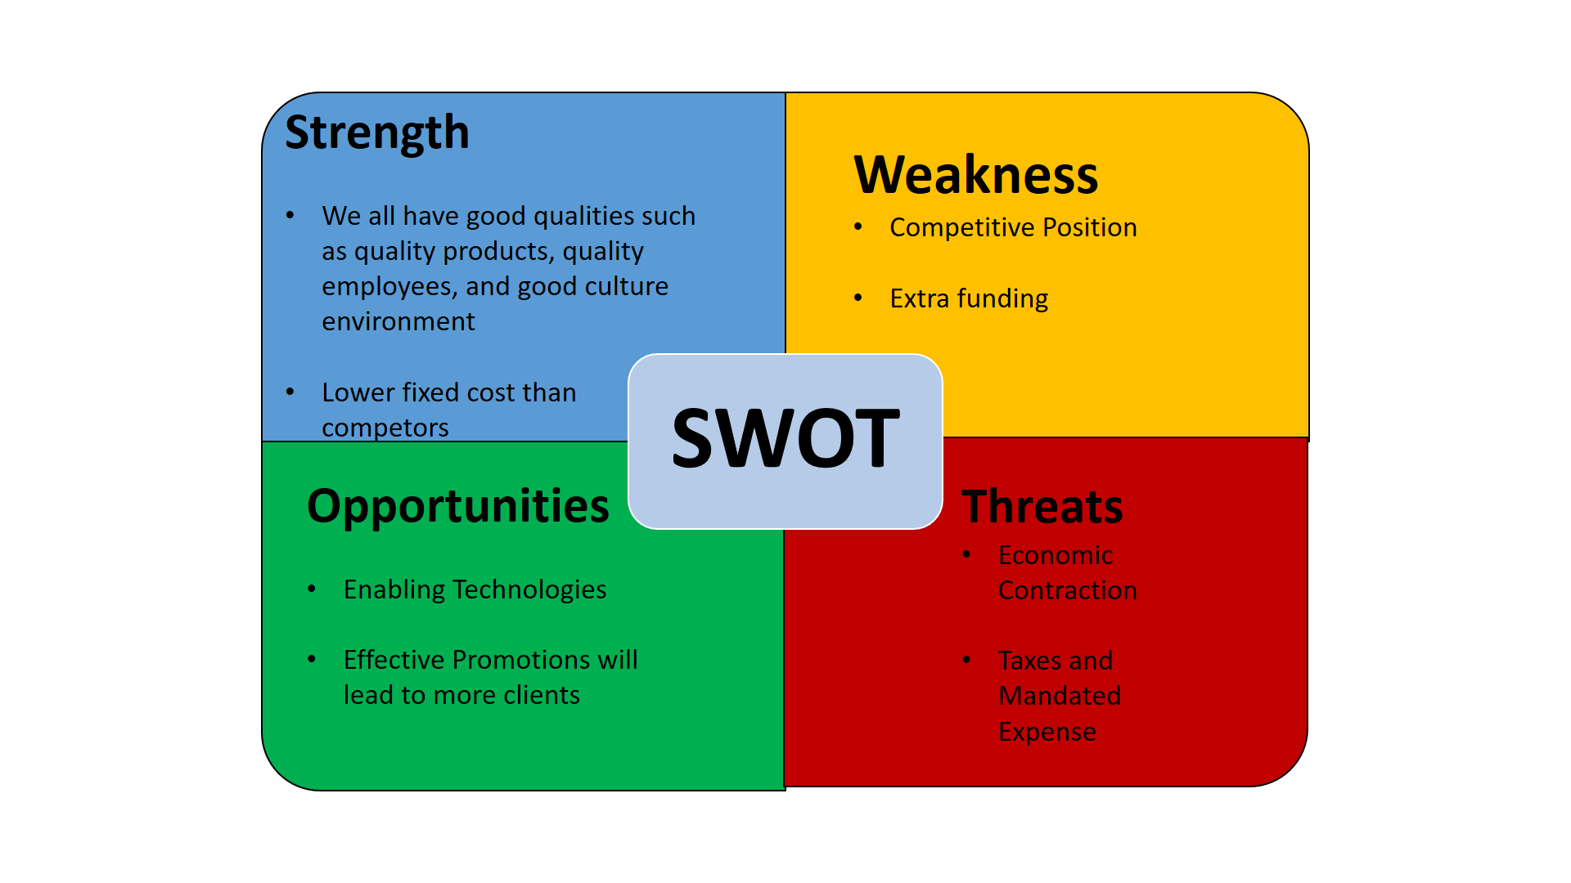

**Industry Analysis**

**Threat of New Entrants**

        The risk of new competitors coming into the same industry is inevitable especially now that many businesses are growing rapidly and want their customer service outsourced from well-known companies. Hence, our company is committed to creating strong brand loyalty, and building solid market visibility that also offers special benefits with limited pricing which also makes the threat low for new entrants.

**Bargaining Power of Buyer**

The Optimist BV company takes into consideration the four major factors when determining the bargaining power of buyers in the market:

·         Number of buyers relative to suppliers

·         Dependence of a buyer’s purchase on a particular supplier

·         Switching costs

·         Backward Integration

These are volatile and depends on the current market price.

**Bargaining power of supplier**

There are 5 main factors when determining the bargaining power of suppliers:

·         Number of suppliers as compared to the buyers

·         How much a buyer is dependent on the supplier’s sale

·         Switching cost of the suppliers

·         Availability of the suppliers for immediate purchase

·         Possibility of forward integration by suppliers

In the company of Optimist BV, the bargaining power of suppliers is relatively low and not an issue for the company.

**Threat of substitutes**

             The threat of substitutes on having our product and availing our services is low because our product is quality than other competitors. In this industry, the needed money or capital is high which also makes the business owners hesitant to venture. Our product has its technicality to just imitate which makes it irreproducible and superior to other products. Our pricing also is more cost-effective than other substitutes which make the consumer switching cost high.

**Competitive rivalry between existing**

             Upon designing and analyzing our company, we put our branches in a non-competitive environment in which we make sure that we are the only provider and unique in this environment and there are no existing firms and intense competition.  If and only if there’s a competitor, we are long enough committed to satisfying our clients with our product and service, we know that our product highlights the differences and needs of the clients.

**Conclusions and recommendations**

**Conclusions**

Upon examining and analyzing - our target market and buyers would be found mostly on social media and it would be effective and efficient if we will be focusing our promotions and engagements through digital marketing.

**Awareness of the market**

                             The company strategy to increase our awareness of the market was to partner with companies that have a strong trust signal. Our goal is to partner with big-name companies and have a great partnership with them to achieve a great level of loyalty and trust to make us successful. another way to increase our market awareness is to be aware of what's happening around our field and know what the other competitors are doing, what’s the latest trend, and what's popping off the market we will not solely focus on what’s our main product Optimist B.V. will go for growth of the company.

**Usage of the product**

                              The usage of our product is to help the blind in their daily lives and solely on walking on streets and to seek safety for our users in their daily routines. our product will focus on having the safest route for our users or consumers and the easiest for them to navigate or follow. As a company that is looking for growth we also do outsourcing were looking for something new to add to our product line we look for other products that is outside of our companies premises.

**Buyer info**

                             Our buyer info will be based on research, our buyers will be the one who has disabilities in their sight based on an article entitled “what do blind people see?’ which totally blind describes people who have no light perception or NLP, or person doesn't see light at all. In the same article, they said that blindness is an ‘all or nothing’ condition cause most people with vision loss aren’t completely blind. they may have some sight, which means they have low vision. they may have some residual vision, which could allow them to see light or color, or shapes.

**Patronage maintenance**

                             To maintain our patronage we planned to make our customers to be always satisfied to maintain our patronage. Because without our customers it will be hard for our company to get going of business that is why our goal is to have all of our customers satisfied at all costs.

**Brand image, slogan,**



                “**Let's make our journey become safety**”

**Strengths of the company**

                              The greatest strength of Optimist B.V. is that our company is innovative and has a unique product. our company likes to create an innovative and unique products and the best example of that is our vision way finder is an app developed for your smartphone to be an eye for you and to navigate your way to your destination and help you get there safely and our company can bear to seize opportunities and defend our self to threats. When opportunities comes our company initially grabs it and when threats come we face it and get through it.

**Buying behavior of your target market**

                               The buying behavior of our target market is habitual behavior Habitual buying behavior occurs when involvement is low and differences between brands are small. Consumers in this case usually do not form a strong attitude toward a brand but select it because it is familiar. In these markets, promotions tend to be simple and repetitive so that the consumer can, without much effort, learn the association between a brand and a product class. Marketers may also try to make their products more involving. For instance, toothpaste was at one time purchased primarily out of habit, but Procter & Gamble introduced a brand, Crest toothpaste, that increased consumer involvement by raising awareness about the importance of good dental hygiene.

**Recommendations**

                Our company should be continuing to innovate and establish a good relationship with our customers and for our employees and have them a good and healthy work environment.

**Limitations**

* Problem of Rapid Change

             The current market is characterized by rapid changes. Whatever is useful or relevant today will be obsolete tomorrow. Marketing research can't keep up with the pace of change. The research findings or outcomes that are available after a certain time period appear to be irrelevant or meaningless.

* Cost Consideration

             It is a luxury to undertake systematic marketing research. For study design, data collecting, data analysis, interpretation, and report creation, a company requires funds. Fees for statisticians and computer professionals are high. When market research is undertaken on a regular basis, a company must have its own well-equipped marketing research department. Market research has gotten more expensive. As a result, medium and small businesses find it difficult to afford.

* It cannot Eliminate Risks Inherent in Decision-making

            There is risk and uncertainty in every economic decision. Risk and uncertainty are inherent in marketing research. It is an attempt to reduce the amount of danger. As a result, high marketing research costs do not ensure safety or certainty

**Appendix**

1.1 Popularly recognized by this product mainly for PWD sectors.

* 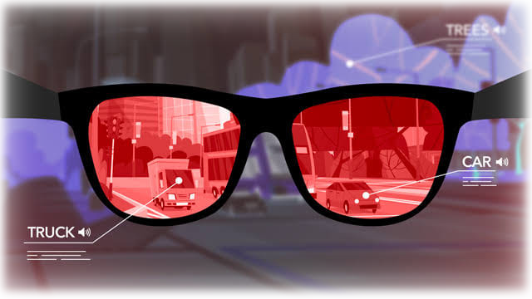Wearable AI vision eyeglasses

1.2 Infographic 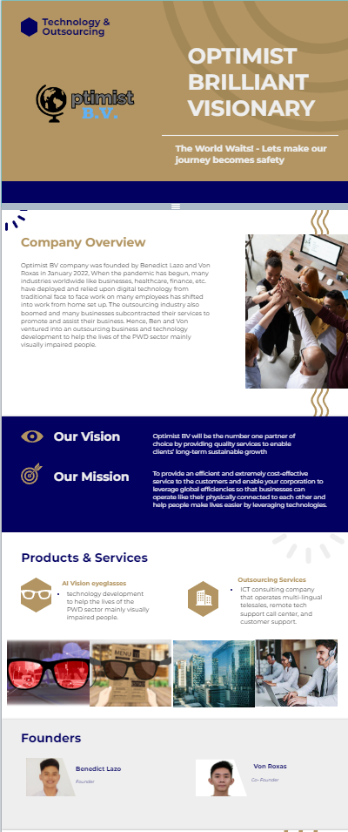Chart

